DIY 2G Android Phone with Gesture Interface

This 2G android mobile phone will work as an ordinary smartphone. This innovative system is powered by Raspberry Pi, the circuit consisted of, a touch screen display, GSM/GPRS module, battery, battery charge control circuit, and vibration motor. On the Raspberry Pi touch display, there will be 3 interfaces on screen. In the Dial interface there will be an option to enter the number and accordingly to dial on that number, there is an option to view contacts and from the contact list itself we can dial or send an SMS to a particular number, there is a separate interface to send pre-defined SMS to a number, also if any call is received by phone there is a vibration motor to provide haptic feedback to the user, this system is portable is powered using a rechargeable battery through a battery charging circuit which will prevent the battery from overcharge, over-discharge and also provide short circuit protection. The battery level is also indicated on the screen.

Block Diagram:
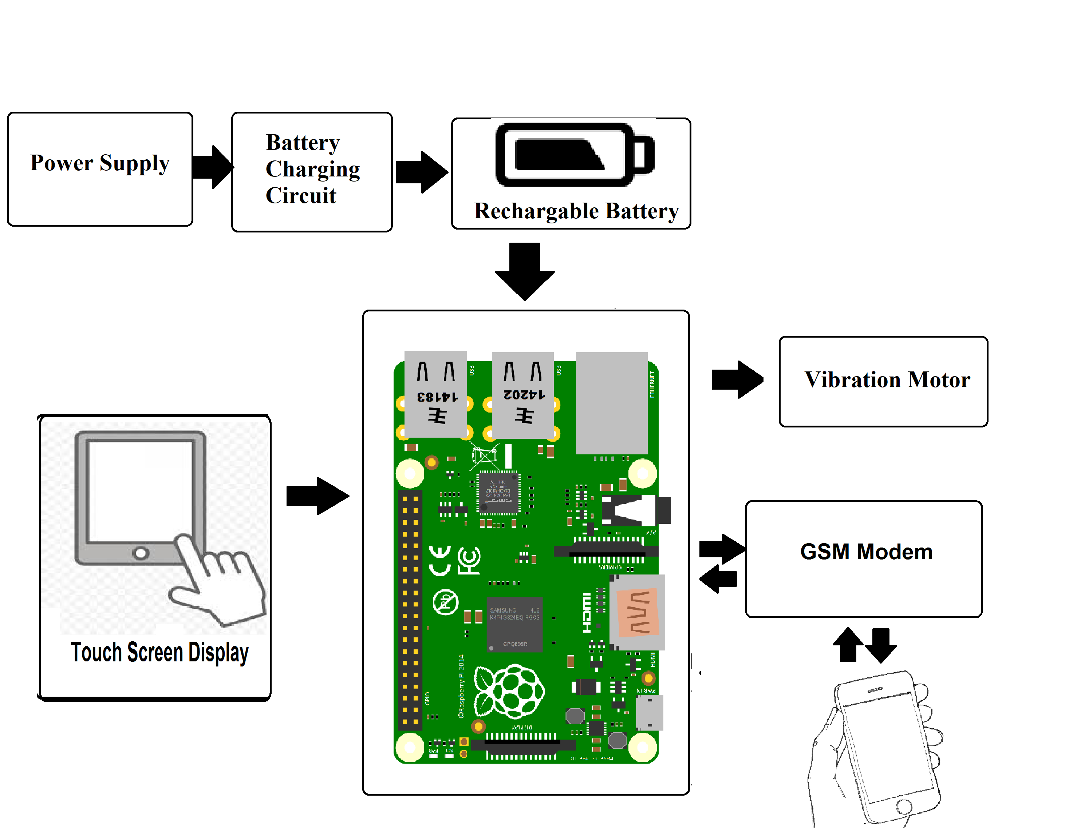

Hardware Specifications

- Raspberry pi

- GSM module

- touch screen display

- vibration Motor

- battery charge circuit

- Resistors

- Capacitors

- Cables and Connectors

- Diodes

- PCB and Breadboards

- LED

- Transformer/Adapter

- Push Buttons

- Switch

- IC

- IC Sockets

Software Specifications

- Python 3 compiler
- Programming Language: Python

